EXP NO: 1

1)Create numeric, character, and logical vectors and display type and content.
Program (R)
# Aim: Create numeric, character and logical vectors

# Numeric vector
num <- c(10, 20, 30, 40, 50)

# Character vector
char <- c("Apple", "Mango", "Orange")
# Logical vector
logic <- c(TRUE, FALSE, TRUE)
# Display content
print(num)
print(char)
print(logic)
# Display type
print(typeof(num))
print(typeof(char))
print(typeof(logic))

output
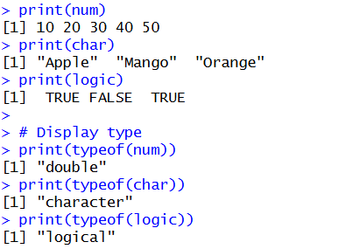

EXP NO: 2

2. Create labeled matrices (5×4, 3×3, 2×2) filled by row/column.
Program (R)
# Create a 5x4 matrix filled by row
m1 <- matrix(1:20, nrow=5, ncol=4, byrow=TRUE)
rownames(m1) <- c("R1", "R2", "R3", "R4", "R5")
colnames(m1) <- c("C1", "C2", "C3", "C4")
print(m1)

# Create a 3x3 matrix filled by column
m2 <- matrix(1:9, nrow=3, ncol=3, byrow=FALSE)
rownames(m2) <- c("A", "B", "C")
colnames(m2) <- c("X", "Y", "Z")
print(m2)

# Create a 2x2 matrix filled by row
m3 <- matrix(1:4, nrow=2, ncol=2, byrow=TRUE)
rownames(m3) <- c("P", "Q")
colnames(m3) <- c("M", "N")
print(m3)

OUTPUT
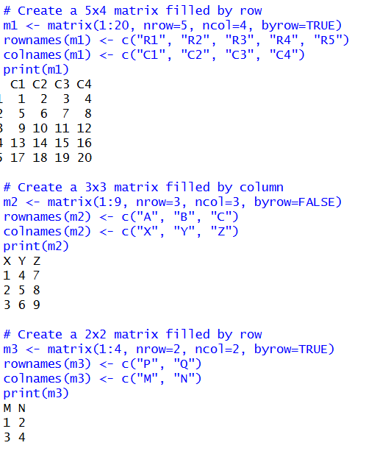

EXP NO: 3
Write an R program to create and display a 3D array with specified rows, columns, and tables.
Program (R)
# Create a 3D array
arr <- array(1:24, dim = c(3, 4, 2))

# Display the 3D array
print(arr)

OUTPUT
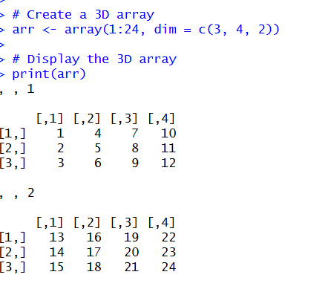

EXP NO: 4

4. Create arrays from vectors with dimension names, print specific element .
Program (R)
# Create a vector
v <- 1:12
# Create an array with dimension names
arr <- array(v,
dim = c(2, 3, 2),
dimnames = list(
Rows = c("R1", "R2"),
Columns = c("C1", "C2", "C3"),
Tables = c("T1", "T2")
))

# Display the complete array
print(arr)
# Print specific elements
print(arr[1, 2, 1])
print(arr[2, 3, 2])
# Print a specific table
print(arr[, , 1])

OUTPUT
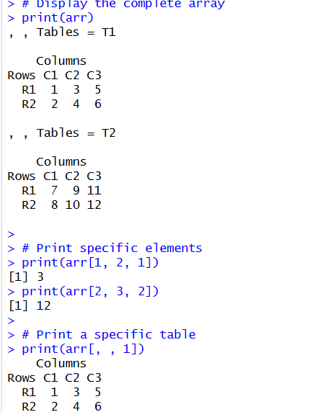
EXP NO: 5

5. Create and manipulate factor variables (e.g., women’s dataset heights, random LETTERS sample).
Program (R)
# Create a vector
v <- 1:12
# Create an array with dimension names
arr <- array(v,
dim = c(2, 3, 2),
dimnames = list(
Rows = c("R1", "R2"),
Columns = c("C1", "C2", "C3"),
Tables = c("T1", "T2")
))

# Display the complete array
print(arr)
# Print specific elements
print(arr[1, 2, 1])
print(arr[2, 3, 2])
# Print a specific table
print(arr[, , 1])

OUTPUT
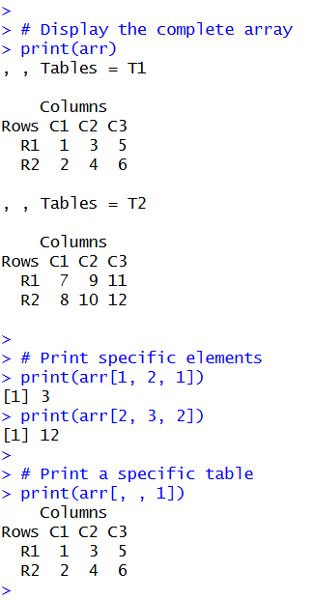

EXP NO: 6

6. Create an R list containing vectors, matrices, and functions; display contents.
Program (R)
# Create a vector
v <- c(10, 20, 30, 40)
# Create a matrix
m <- matrix(1:6, nrow=2, ncol=3)
# Create a function
add <- function(a, b) {
return(a + b)
}
# Display the complete list
print(mylist)
# Display individual contents
print(mylist$Vector)
print(mylist$Matrix)
# Display function
print(mylist$Function)
# Call the function
print(mylist$Function(5, 3))
OUTPUT
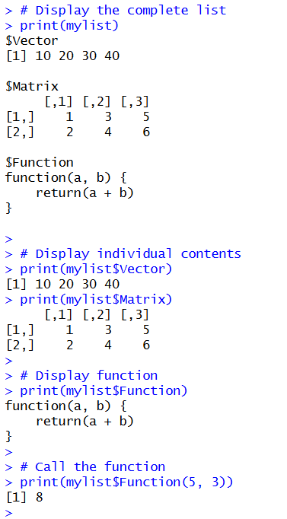
EXP NO: 7

7. Write R programs for basic tasks: Factors of a number, generate a vector of 10 random integers between -50 and 50, print numbers 1–100 with FizzBuzz logic.
# 1. Find factors of a number
n <- 12
cat("Factors of", n, "are:\n")
for (i in 1:n) {
if (n %% i == 0) {
cat(i, " ")
}
}
cat("\n\n")
# 2. Generate 10 random integers between -50 and 50
set.seed(10)
x <- sample(-50:50, 10, replace = TRUE)
cat("Random integers:\n")
print(x)

OUTPUT
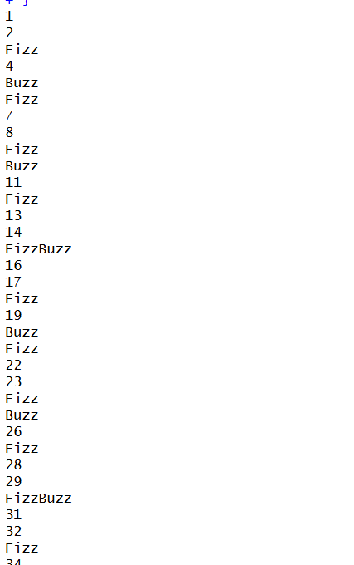
EXP NO: 8
8 Generate random number from a normal distribution: count occurrences.
Program (R)
# Generate random numbers from normal distribution
set.seed(10)
x <- rnorm(100, mean = 50, sd = 10)
# Display random numbers
print(x)
# Count occurrences of each rounded value
rounded_x <- round(x)
count <- table(rounded_x)
# Display occurrence counts
print(count)
output

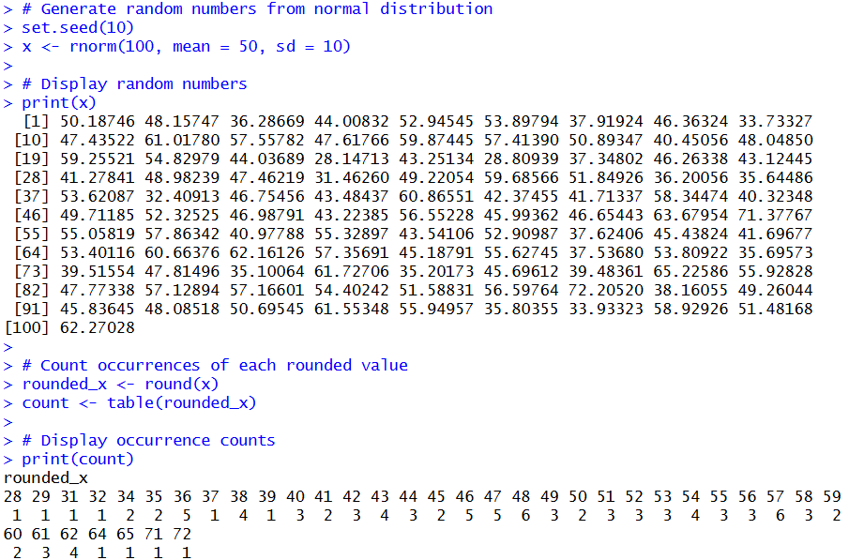

EXP NO: 9
9. Create empty plots with specified axis limits.

Program (R)
# Create an empty plot with specified axis limits
plot(0, 0,
type = "n",
xlim = c(0, 10),
ylim = c(0, 20),
xlab = "X-axis",
ylab = "Y-axis",
main = "Empty Plot")

output:
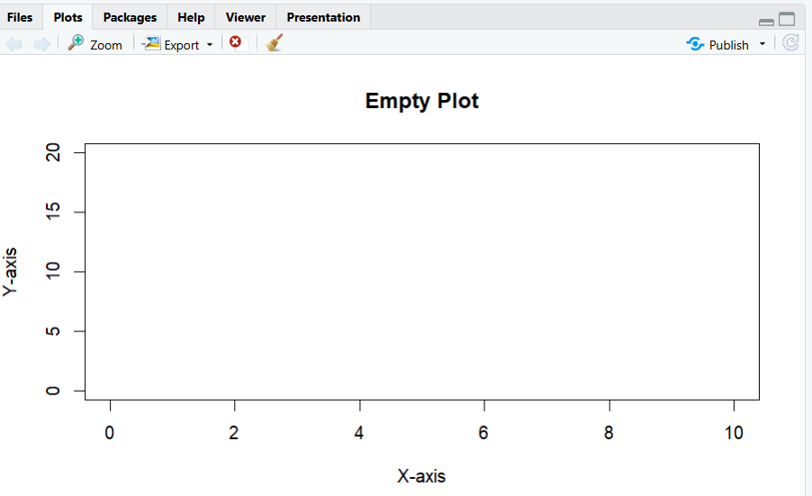

EXP NO: 10
10. Create and explore a data frame exam_data with name, score, attempts, and qualifying fields. Perform extract, add row/column, sort, save to file.
Program (R)
# 1. Create a data frame
exam_data <- data.frame(
name = c("Anu", "Bala", "Charan", "Divya", "Ezhil"),
score = c(85, 45, 72, 90, 55),
attempts = c(1, 2, 1, 1, 3),
qualifying = c(TRUE, FALSE, TRUE, TRUE, TRUE)
)

# 2. Display the data frame
print(exam_data)

# 3. Explore the data frame
print(str(exam_data))
print(summary(exam_data))
print(nrow(exam_data))
print(ncol(exam_data))

# 4. Extract a column
print(exam_data$name)

# Extract a specific row
print(exam_data[1, ])

# Extract a specific value
print(exam_data[2, "score"])

# 5. Add a new column
exam_data$grade <- c("A", "C", "B", "A", "B")
print(exam_data)

exam_data <- rbind(exam_data, new_row)
print(exam_data)
# 7. Sort by score in ascending order
sorted_data <- exam_data[order(exam_data$score), ]
print(sorted_data)
# 8. Save data frame to CSV file
write.csv(exam_data, "exam_data.csv", row.names = FALSE)
cat("Data saved successfully!")

output

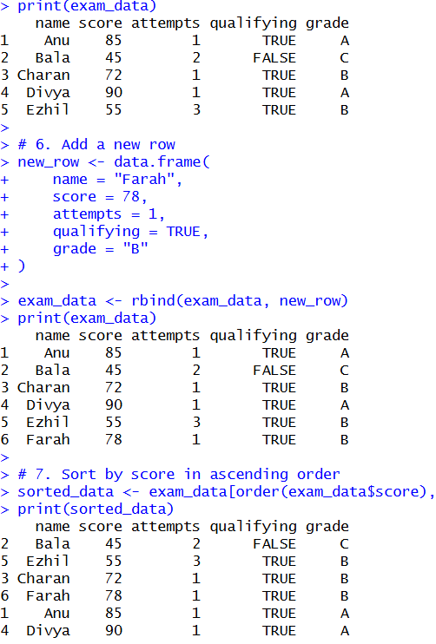

EXP NO: 11
11. Write an R program to read a .csv file and display contents.
Program (R)
exam_data <- data.frame(
name = c("Anu", "Bala", "Charan", "Divya", "Ezhil"),
score = c(85, 45, 72, 90, 55),
attempts = c(1, 2, 1, 1, 3),
qualifying = c(TRUE, FALSE, TRUE, TRUE, TRUE)
)

write.csv(exam_data, "exam_data.csv", row.names = FALSE)

output:
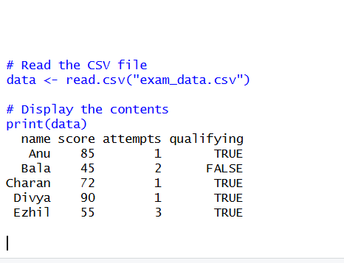

EXP NO: 12
12. Perform data reshaping on air quality dataset: melt, cast, compute monthly averages for Ozone, Solar.R, Wind, and Temperature.
Program (R)
# Load the built-in airquality dataset
data(airquality)
# Display the dataset
print(head(airquality))
# Select required columns
aq <- airquality[, c("Month", "Day",
"Ozone", "Solar.R", "Wind", "Temp")]
)

# Display melted data
print(head(melt_data))

# Cast data and calculate monthly averages
monthly_avg <- dcast(
melt_data,
Month ~ Measurement,
fun.aggregate = function(x) mean(x, na.rm = TRUE)
)

# Display monthly averages
print(monthly_avg)
Output:
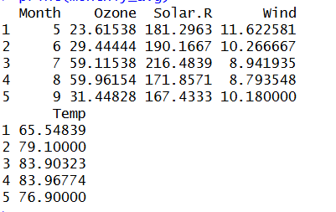

EXP NO: 13
13. Combine multiple arrays row-wise.
Program (R)
# Create first array
a1 <- array(1:6, dim = c(2, 3))

# Create second array
a2 <- array(7:12, dim = c(2, 3))

# Display combined array
cat("Combined Array:\n")
print(result)

output
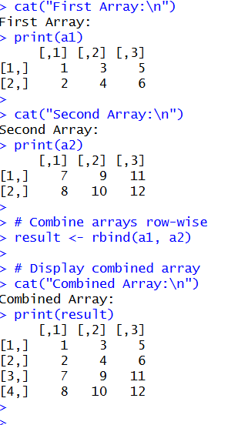

EXP NO: 14
14. Explore and manipulate ChickWeight dataset (sorting, melting, casting by Diet).
Program (R)
# Load dataset
data(ChickWeight)
# Display data
head(ChickWeight)
summary(ChickWeight)

# Sort by weight
sorted <- ChickWeight[order(ChickWeight$weight), ]
print(head(sorted))

print(result)

output:
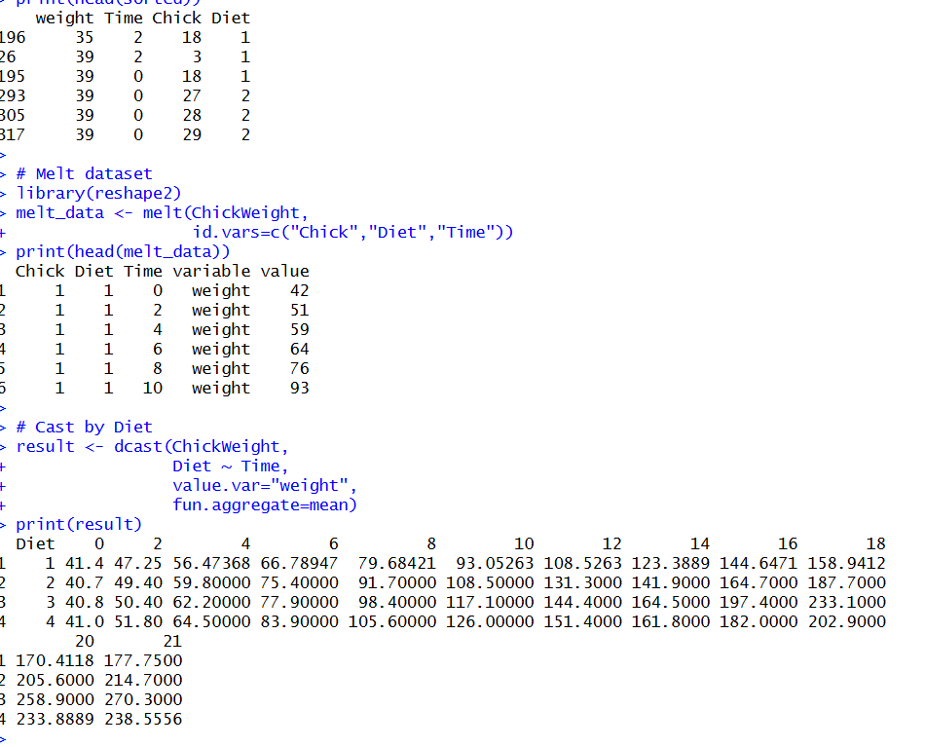

EXP NO: 15
15. Perform EDA on iris dataset: dimensions, summary, standard deviation,quantiles, grouping by Species, pivot table, categorical grouping with Sepal.Length categories.
Program (R)
# Load dataset
data(iris)
# Dimensions and summary
dim(iris)
summary(iris)
# Standard deviation and quantiles
sapply(iris[1:4], sd)
sapply(iris[1:4], quantile)
# Group by Species
aggregate(. ~ Species, data=iris, mean)
# Pivot table
xtabs(~ Species + cut(Sepal.Length, 3), data=iris)
# Categorical grouping
iris$Category <- cut(iris$Sepal.Length,
breaks=3)
table(iris$Category)

output:
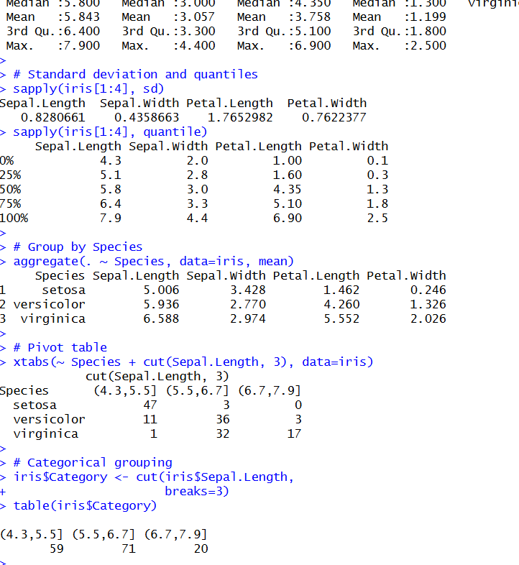

EXP NO: 16

16. Explore USArrests dataset: summary statistics, state with largest rape arrests, max & min murder rates, correlation among features, states above median assault arrests and bottom 25% for murder, visualization with histogram, density, scatterplots, bar graphs.
Program (R)

# Load dataset
data(USArrests)
# 1. Summary statistics
print(summary(USArrests))
# 2. State with largest rape arrests
print(rownames(USArrests)[which.max(USArrests$Rape)])
# 5. States above median Assault
# and bottom 25% Murder
result <- subset(USArrests,
Assault > median(Assault) &
Murder <= quantile(Murder, 0.25))
print(result)

output
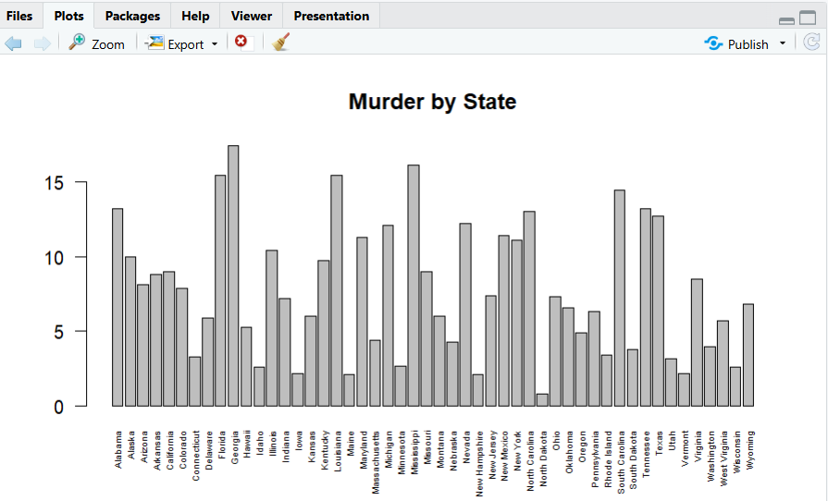

EXP NO: 17
17. Explore Titanic dataset: bar chart of survival vs class, modify plot by gender, histogram of Age.
Program (R)
# Load Titanic dataset
data(Titanic)

# 1. Bar chart: Survival vs Class
survival <- margin.table(Titanic, c(2, 4))
barplot(survival, beside=TRUE,
legend=TRUE,
main="Survival vs Class",
xlab="Class", ylab="Count")

# 2. Modify plot by Gender
gender_survival <- margin.table(Titanic, c(2, 4, 1))
barplot(gender_survival[,,1],
beside=TRUE, legend=TRUE,
main="Survival by Gender",
xlab="Class", ylab="Count")

output:
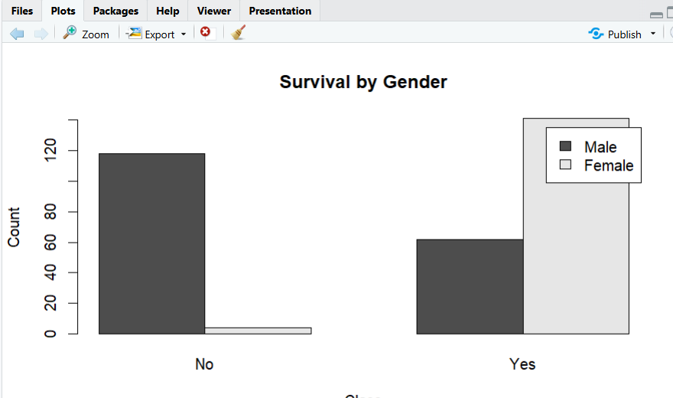

EXP NO: 18
18. Create graphs in R: boxplot, histogram, bar plot, line chart, scatter plot.
Program (R)
# Sample data
x <- c(10, 20, 30, 40, 50)
y <- c(15, 25, 20, 45, 60)
# 1. Boxplot
boxplot(x, main="Boxplot", col="lightblue")
# 2. Histogram
hist(x, main="Histogram", col="lightgreen")
# 3. Bar plot
barplot(x, main="Bar Plot", col="orange")
# 4. Line chart
plot(x, y, type="l",
main="Line Chart", col="blue")
# 5. Scatter plot
plot(x, y, main="Scatter Plot",
xlab="X", ylab="Y", pch=19)

output
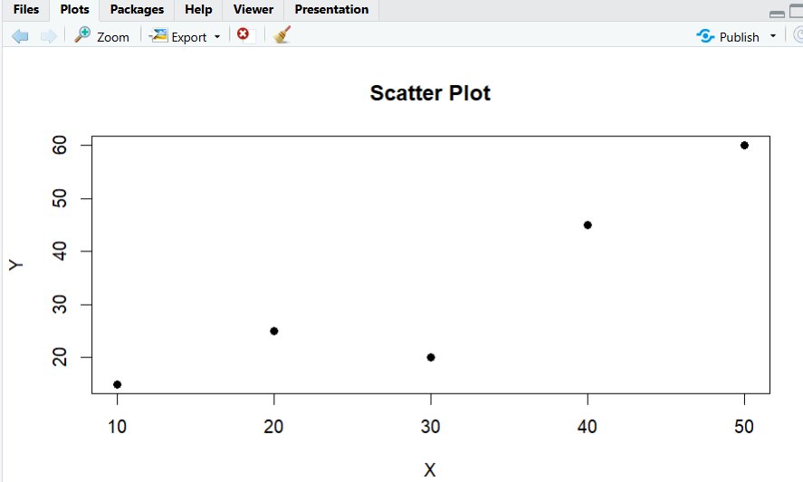

EXP NO: 19
19. Build a regression model on advertising dataset (Sales ~ Spend) and predict Sales.
Program (R)
# Create Advertising dataset
Spend <- c(10, 20, 30, 40, 50)
Sales <- c(15, 25, 35, 45, 55)

data <- data.frame(Spend, Sales)
print(data)

# Build regression model
model <- lm(Sales ~ Spend, data = data)
print(summary(model))

# Predict Sales
new_data <- data.frame(Spend = 60)
prediction <- predict(model, newdata = new_data)

print(prediction)
output
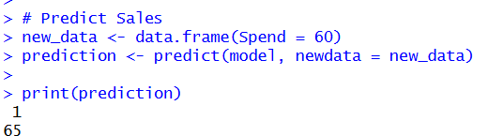

EXP NO: 20
20. Create multiple regression model using ChickWeight dataset with “Time” and “Diet” as predictors; predict weight and compute model error.
Program (R)
# Load dataset
data(ChickWeight)
df <- ChickWeight

# Build multiple regression model
model <- lm(weight ~ Time + Diet, data = df)
print(summary(model))

# Predict weight
pred <- predict(model, newdata = df)

# Calculate model error
MAE <- mean(abs(df$weight - pred))
MSE <- mean((df$weight - pred)^2)
RMSE <- sqrt(MSE)

Output:
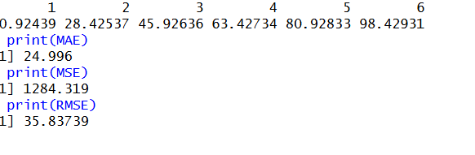

EXP NO: 21
21. Randomly split iris dataset into train/test (80/20), build logistic regression (Species ~ Petal.Length + Petal.Width), predict, and evaluate with confusion matrix.
Program (R)
# Load dataset
data(iris)
set.seed(123)

# Split data into 80% training and 20% testing
index <- sample(1:nrow(iris), 0.8 * nrow(iris))
train <- iris[index, ]
test <- iris[-index, ]

# Build logistic regression model
model <- multinom(Species ~ Petal.Length + Petal.Width,
data = train)

# Predict species
pred <- predict(model, newdata = test)

# Confusion matrix
print(table(Actual = test$Species, Predicted = pred))

output
